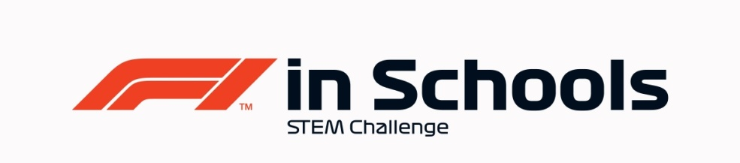
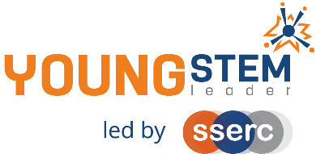
Young STEM Leader & F1 in Schools
Auto-award agreement: Primary Class and YSL2 Non-Formal
This document details how participants in the Primary Class of F1 in Schools can be presented for the Young STEM Leader Award at Curriculum for Excellence Second Level (YSL2).
The table below provides guidance on the how the tasks, activities and learning experiences associated with Primary Class of F1 in Schools will provide effective evidence in meeting the learning outcomes of the YSL2 award. Professional judgement should always be used. Alternative examples/methods of evidence are acceptable provided these meet the associated learning outcome(s) of the badges.
YSLP Badge | Corresponding F1 in Schools activity | Notes
Discover  the meaning and importance of STEM | Introduction to STEM and F1 in Schools STEM Competition.  Choosing team roles and researching where F1 in Schools participants can lead. | - Stereotypes and misconceptions can be covered in a general setting such as initial induction to F1 in Schools or other learning event.  - Can also be covered independent of F1 in Schools as a stand-alone learning activity.  - Careers work can be supported using the F1 in Schools alumni exemplars.
Create  and plan a STEM activity, event or interaction | Participation in the competition, creating car, folio, garage display and future vision elements to be displayed and judged at the final event.  Practise presentations and feedback.  Risk Assessment and safe working procedures for using equipment to manufacture car and garage display. Also for F1 in Schools final event. | - When considering resources and materials for car and garage display, teams should consider the sustainability of these resources- e.g. can they be recycled? Are they from a sustainable source?  - Teams should be aware of risks associated to the activities and be part of developing procedures to minimise risk.
Inspire  others in STEM | Research of existing F1 teams and successful car designs, developing Future Visions.  Any promotion of F1 in Schools/STEM- e.g. STEM Fair, stall at Parents Evening etc. | - F1 in Schools alumni exemplars can be used as further research material to inspire teams.
Lead  a STEM activity, event or interaction | Participation throughout competition- each young person leading the area they are responsible for.  Young people should respond to feedback. | - Evidence for this may be observed in team meetings, and participants should reflect on this in their presentation.
Overall | All | The entirety of Primary Class F1 in Schools Regional Finalists work should be considered to encapsulate all four badges at YSL2.  Evidence of young people having achieved all four badges should be viewed holistically as part of the F1 in Schools event, where the Folio, Car, and Presentations will be delivered and judged, along with the display of their Pit Garage and Future Visions for F1.

F1 in Schools Primary Class
Nomination for Young STEM Leader Award at CfE Second Level (YSL2)
Declaration
To be completed by the appropriate school staff member.
I/we can confirm that the members of our project team have:
Action | Y/N
F1 in Schools approval for this nomination
Completed the Design & Engineering Folio
Completed their Car
Completed the Future Vision of F1
Promoted STEM/F1 in Schools within their setting
Delivered their final presentation and built their Pit Garage Display
Learned and developed in alignment with the four badges of YSL2

Staff name:
School:
Number of learners to be certificated:
Year group:
Date:

This completed declaration should be emailed to youngstemleader@sserc.scot who will action the certification process for the learners. Please make the subject of the email “F1 in Schools YSL2 certification request”. You must cc Mark Wemyss-Holden in this email.
Please also attach a sample of the evidence generated during F1 in Schools that satisfies the award agreement as detailed above.

