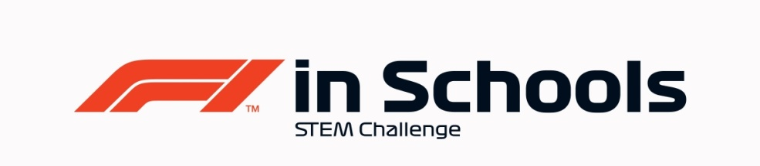
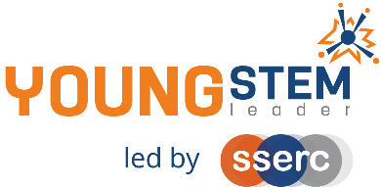
Young STEM Leader & F1in Schools
Auto-award agreement: Professional Class Regional Finalists and YSL5
This document details how participants in the Professional Class of F1 in Schools Regional Finalists can be presented for the Young STEM Leader Award at SCQF Level 5 (YSL5).
The table below provides guidance on the how the many tasks, activities and learning experiences associated with Professional Class of F1 in Schools at Regional Level will provide effective evidence in meeting the learning outcomes of the Young STEM Leader Award at SCQF Level 5. Professional judgement should always be used. Alternative examples/methods of evidence are acceptable provided these meet the associated learning outcome(s).
YSLP Learning Outcome | YSLP Log task | Corresponding F1 in Schools activity | Notes
LO1  The skills, qualities and behaviours required for STEM leadership | 1 | Launch, induction activity, team building, SWOT Analysis and/or other suitable. | Can be done in a general setting such as initial induction to F1 in Schools or other independent learning event.  Can also be covered independent of F1 in Schools as a stand-alone learning activity.
LO2  Set an action plan to develop STEM leadership skills, qualities and behaviours | 2 | Team building/team meetings, applying for/suitability for roles within the team, evaluation of team progress and/or other suitable. | Can be linked to any relevant self-evaluation exercise or as part of the team building activities and included in the Enterprise portfolio. Also evidenced in record of team meetings.
LO3  Understand how STEM activities, events and interactions can be used to promote opportunities in STEM | 3 | Launch day or any other point during F1 in Schools where young people read competition guidelines and become aware of local, national and worldwide opportunities related to STEM and F1 in Schools. | Can be done in a general setting such as initial induction to F1 in Schools. Also part of the team reflection in the Verbal Presentation, where team members explain what they have learned during the competition, and how this has inspired their future plans in STEM.  Also covered via links with sponsors and STEM companies- teams develop an awareness of how local and national companies operate and the opportunities they provide. They also develop links which can lead to work placements and future employment.
LO4  Understand how duty of care affects the safeguarding of participants  LO5  Understand the importance of safety when leading STEM activities, events or interactions | 4  5 | Any relevant point where Health and Safety is involved: practical workshops, operating CAD/CAM equipment to produce F1 Race Cars and Team Merchandise, company visit, building of pit display, risk assessments, etc.  Also when teams are allowing others to use F1 in Schools equipment for educational/promotional reasons. | Can be done during company visits, workshops, practical learning and of course in participating in the Regional Final event, considering the F1 in Schools Risk Assessment.  Also at events promoting and fundraising for F1 in Schools, where pupils will create or amend a Risk Assessment.
LO6  Plan STEM activities, events or interactions  LO7  Be able to lead STEM activities, events or interactions  LO8  Be able to evaluate a STEM activity, event or interaction | 6AB  7AB  8AB | The planning and delivery of all practical work and leadership activity required to be successful at Regional Finals.  Final presentation to judging panel and Pit Display. The Design & Engineering and Enterprise Folio will also provide a range of evidence. | Evidence of this may be found in all submissions for F1 in Schools Regional Final.  Additional leadership activity such as supporting junior teams, working with primaries or leading school assemblies will supplement evidence.
LO1 through 8 | All | All | The entirety of Professional Class F1 in Schools Regional Finalists work should be considered to encapsulate all eight LOs of YSLP at SCQF Level 5. Evidence of young people having achieved all eight LOs should be viewed holistically as part of the Regional Finals event, where the Folios, Cars, Social Media plans and Sponsorships will be submitted as well as the Presentations delivered and Pit Display judged.

F1 in Schools Development Class National Finalists
Nomination for Young STEM Leader Award at SCQF Level 5
Declaration
To be completed by the appropriate school staff member.
I/we can confirm that the members of our project team have:
Action | Y/N
F1 in Schools approval for this nomination
Completed the Design & Engineering and Enterprise Folios
Engaged with Sponsors and Mentors locally and nationally
Become aware of Further Education, Higher Education and Apprenticeship opportunities in STEM available and suited to them
Promoted STEM/F1 in Schools on social media and within their setting
Delivered their final presentation and built their Pit Display
Learned and developed in alignment with and coverage of the eight learning outcomes of YSL5

Staff name:
School:
Number of learners to be certificated:
Year group:
Date:

This completed declaration should be emailed to youngstemleader@sserc.scot who will action the certification process for the learners. Please make the subject of the email “F1 in Schools YSL5 certification request”. You must cc Mark Wemyss-Holden in this email.
Please also attach a sample of the evidence generated during F1 in Schools that satisfies the award agreement as detailed above. (e.g. Script or Powerpoint of Verbal Presentation, Enterprise Folio, Design & Engineering Folio, Social Media Plans etc)

