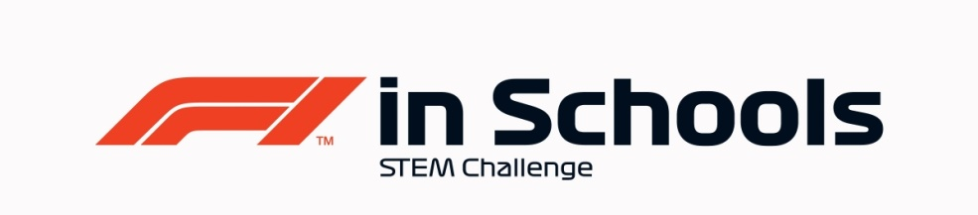
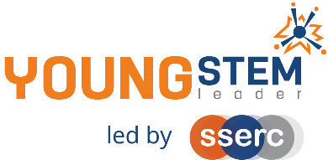
Young STEM Leader & F1in Schools
Auto-award agreement: Professional Class National Finalists and YSL 6
This document details how participants in the Professional Class of F1 in Schools National Finalists can be presented for the Young STEM Leader Award at SCQF Level 6 (YSL6).
The table below provides guidance on the how the many tasks, activities and learning experiences associated with Professional Class of F1 in Schools at National Level will provide effective evidence in meeting the learning outcomes of the Young STEM Leader Award at SCQF Level 6. Professional judgement should always be used. Alternative examples/methods of evidence are acceptable provided these meet the associated learning outcome(s).
YSLP Learning Outcome | YSLP Log task | Corresponding F1 in Schools activity | Notes
LO1  Understand the skills and qualities needed for effective, inclusive leadership | 1 | Launch, induction activity, team building, SWOT Analysis and/or other suitable. | Can be done in a general setting such as initial induction to F1 in Schools or other independent learning event.  Can also be covered independent of F1 in Schools as a stand-alone learning activity.
LO2  Be able to evaluate and develop leadership skills and qualities | 2 | Team building/team meetings, applying for/suitability for roles within the team, evaluation of team progress and/or other suitable. | Can be linked to any relevant self-evaluation exercise or as part of the team building activities and included in the Enterprise portfolio. Also evidenced in record of team meetings.
LO3  Understand the purpose of STEM activities, events and interactions | 3 | Launch day or any other point during F1 in Schools where young person has considered the negative issues in STEM such as stereotypes, misconceptions, outdated views, elitism, gender imbalance, elitism, etc. | Can be done in a general setting such as initial induction to F1 in Schools. Also part of the team reflection and promotional posts on Social Media accounts and promotion to others within their setting.
LO4  Understand how duty of care affects the safeguarding of participants  LO5  Understand how to maximise safety when leading STEM activities, events or interactions | 4  5 | Any relevant point where Health and Safety is involved: practical workshops, operating CAD/CAM equipment, company visit, building of pit display, risk assessments, etc.  Also when teams are allowing others to use F1 in Schools equipment for educational/promotional reasons. | Can be done during company visits, workshops, practical learning and of course in participating in Regional and National Final events, considering the F1 in Schools Risk Assessment.  Also at events such as Race Nights, School Fayre’s and primary liaison visits.
LO6  Plan a series of STEM activities, events or interactions  LO7  Be able to lead a series of STEM activities, events or interactions  LO8  Be able to evaluate a series of STEM activities, events or interactions | 6AB  7AB  8AB | The planning and delivery of all practical work and leadership activity required to be successful at Regional Finals and participate in National Finals.  Final presentation to judging panel and Pit Display. The Social Media Strategy document, and Design & Engineering and Enterprise Folio will also provide a range of evidence. | Evidence of this may be found in all submissions for F1 in Schools National Final..  Additional leadership activity such as supporting junior teams, working with primaries or leading school assemblies will supplement evidence.
LO1 through 8 | All | All | The entirety of Professional Class F1 in Schools National Finalists work should be considered to encapsulate all eight LOs of YSLP at SCQF Level 6. Evidence of young people having achieved all eight LOs should be viewed holistically as part of the assessment week where the Folios, Cars, Social Media and Marketing Strategy will be submitted as well as the Presentations delivered and Pit Display judged.

F1 in Schools Professional Class National Finalists
Nomination for Young STEM Leader Award at SCQF Level 6
Declaration
To be completed by the appropriate school staff member.
I/we can confirm that the members of our project team have:
Action | Y/N
F1 in Schools approval for this nomination
Completed the Design & Engineering and Enterprise Folios
Engaged with Sponsors and Mentors locally and nationally
Became aware of challenges in STEM such as stereotypes, misconceptions and/or outdated views
Promoted STEM/F1 in Schools on social media and within their setting
Delivered their final presentation and built their Pit Display
Learned and developed in alignment with and coverage of the eight learning outcomes of YSL6

Staff name:
School:
Number of learners to be certificated:
Year group:
Date:
This completed declaration should be emailed to youngstemleader@sserc.scot who will action the certification process for the learners. Please make the subject of the email “F1 in Schools YSL6 certification request”. You must cc Mark Wemyss-Holden in this email.
Please also attach a sample of the evidence generated during F1 in Schools that satisfies the award agreement as detailed above. (e.g. Script or Powerpoint of Verbal Presentation, Enterprise Folio, Design & Engineering Folio, Marketing & Social Media Strategy Document etc)

