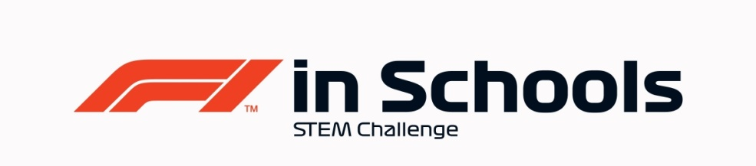
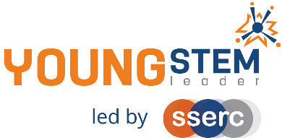
Young STEM Leader & F1 in Schools
Auto-award agreement: Entry Class and YSL3 Non-Formal
This document details how participants in the Entry Class of F1 in Schools can be presented for the Young STEM Leader Award at Curriculum for Excellence Third Level (YSL3).
The table below provides guidance on the how the tasks, activities and learning experiences associated with Entry Class of F1 in Schools will provide effective evidence in meeting the learning outcomes of the YSL3 award. Professional judgement should always be used. Alternative examples/methods of evidence are acceptable provided these meet the associated learning outcome(s) for each of the four badges.
YSLP Badge | Corresponding F1 in Schools activity | Notes
Discover | Introduction to STEM and F1 in Schools STEM Competition.  Choosing team roles and researching where F1 in Schools can lead. | - Meaning and importance of STEM can be covered in a general setting such as initial induction to F1 in Schools or other learning event.  - Can also be covered independent of F1 in Schools as a stand-alone learning activity.  - Careers work can be supported using the F1 in Schools alumni exemplars.
Create | Participation in the competition, creating car, folio, table top pit display and research mission elements to be displayed and judged at the final event.  Practise presentations and feedback.  Researching local STEM companies and looking for support with elements of the competition.  Risk Assessment and safe working procedures for using equipment to manufacture car and garage display. Also for F1 in Schools final event. | - When considering resources and materials for car and garage display, teams should consider the sustainability of these resources- e.g. can they be recycled? Are they from a sustainable source?  - Teams should also consider who needs support with certain aspects of the competition, and who may need support at any promotional events e.g. wheelchair accessible, large print etc.  - Teams should be aware of risks associated to the activities, and be part of developing procedures to minimise risk.
Inspire | Research of existing F1 teams and successful car designers and/or other successful role models in F1.  Research Mission at F1 in Schools event.  Any promotion of F1 in Schools/STEM- e.g.  STEM Fair, stall at Parents Evening etc. | - F1 in Schools alumni exemplars can be used as further research material to inspire teams. Likewise, existing teams within the school competing at higher levels.
Lead | Participation throughout competition- each young person leading the area they are responsible for, and taking onboard feedback.  Research- as above, teams should research inspirational F1/STEM leaders as part of developing their own leadership skills.  Being positive role-models at any promotional events and at F1 in Schools events. | - Evidence for this may be observed in team meetings, and participants should reflect on this in their presentation.  - Teams must promote equality, equity and inclusion in STEM through all interactions with teams and the public.
Evaluation/Feedback and Improvement | All | - Feedback should be sought and acted upon by all team members throughout the journey- e.g. practice presentations, feedback at promotional events, judges feedback during competition etc.
Overall | All | The entirety of Entry Class F1 in Schools work should be considered to encapsulate all four badges of YSLP at Level 3 (Non-Formal).  Evidence of young people having achieved all badges should be viewed holistically as part of the F1 in Schools event, where the Folio, Car, and Research Mission will be judged as well as the Presentation delivered and Table Top Display created.

F1 in Schools Entry Class
Nomination for Young STEM Leader Award at CfE Third Level (YSL3)
Declaration
To be completed by the appropriate school staff member.
I/we can confirm that the members of our project team have:
Action | Y/N
F1 in Schools approval for this nomination
Completed the Design & Engineering Folio
Completed the Car
Completed their Research Mission
Promoted STEM/F1 in Schools within their setting
Delivered their final presentation and built their Table Top Pit Display
Learned and developed in alignment with the four badges of YSL3

Staff name:
School:
Number of learners to be certificated:
Year group:
Date:

This completed declaration should be emailed to youngstemleader@sserc.scot who will action the certification process for the learners. Please make the subject of the email “F1 in Schools YSL3 certification request”. You must cc Mark Wemyss-Holden in this email.
Please also attach a sample of the evidence generated during F1 in Schools that satisfies the award agreement as detailed above (e.g. Script or Powerpoint of Verbal Presentation, Design & Engineering Folio, Table Top Display photos etc).

